NAME : JANUTH ADITHA ABEYSINGHE
STUDENT ID : S225644509
UNIT : SIT725-APPLIED SOFTWARE ENGINEERING
TASK : 4.2P

REPO LINK : https://github.com/Janutimate/week-4.git

SCREENSHOTS :

MongoDB compass:

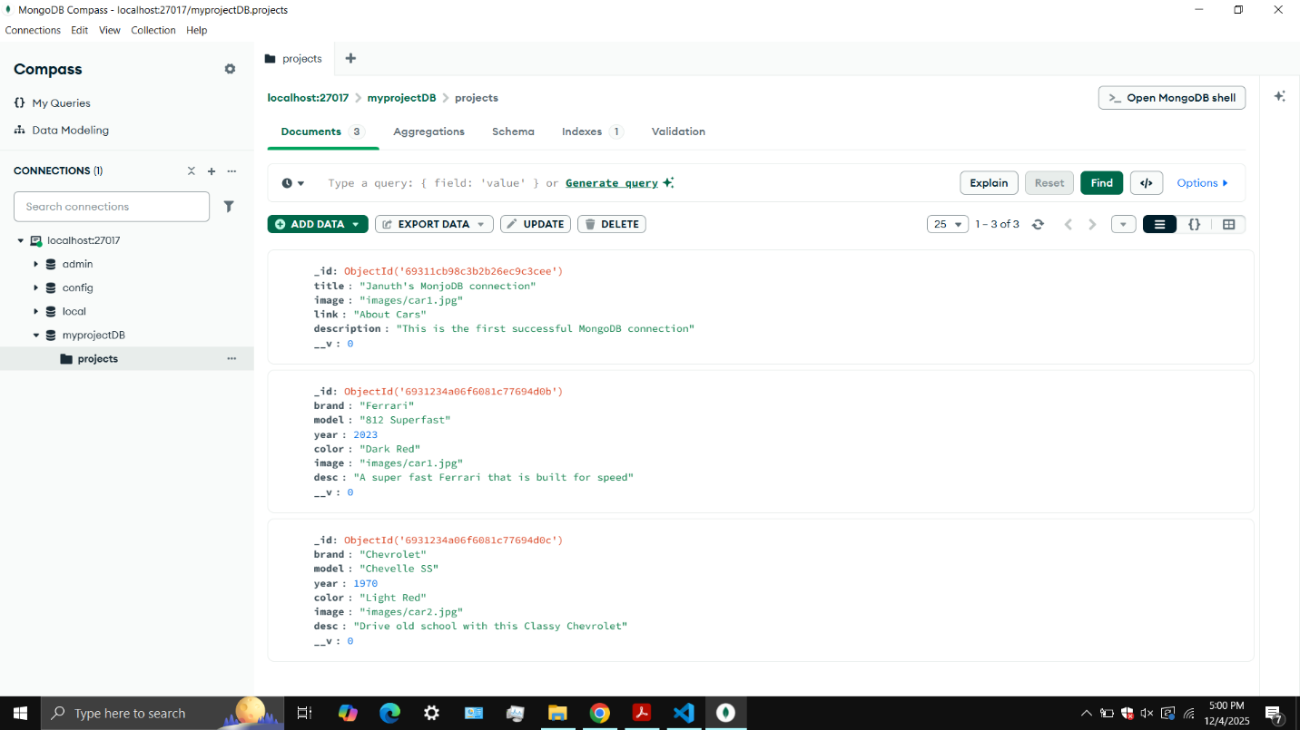

WORKING CODE :

